1. Git-HOL
Here is the complete reference list of every Git command used in this exercise, along with a quick one-line explanation for each:
Configuration & Editor Setup
- git version
  - Checks the currently installed version of Git on your computer.
- git config --global user.name "Your Name"
  - Sets your global Git username associated with your commits.
- git config --global user.email "your_email@example.com"
  - Sets your global email address associated with your commits.
- git config --global --list
  - Displays all saved global Git configuration settings.
- git config --global core.editor "notepad"
  - Sets Windows Notepad as the default editor for Git commit messages.
- git config --global -e
  - Opens the global Git configuration file directly in your default editor for viewing or editing.
Local Repository & File Management
- git init GitDemo
  - Creates and initializes a new local Git repository inside a folder named GitDemo.
- cd GitDemo
  - Navigates your terminal shell into the GitDemo project directory.
- ls -al
  - Lists all files and hidden directories (including .git) in the current folder.
- echo "Welcome to the version control" >> welcome.txt
  - Creates welcome.txt (or appends text to it) with the specified text string.
- cat welcome.txt
  - Displays the full text contents of welcome.txt directly in the terminal.
- git status
  - Displays the current state of the working directory and staging area.
- git add welcome.txt
  - Moves welcome.txt into the staging area to prepare it for a commit.
- git commit
  - Opens your default text editor to write and save a commit message.
- git commit -m "Your message"
  - Commits staged changes directly with an inline message, bypassing the text editor.
- git branch -M main
  - Renames your current active local branch to main.
Remote Repository Operations
- git remote add origin <URL>
  - Connects your local repository to a remote repository URL on GitHub/GitLab.
- git remote set-url origin <URL>
  - Updates or fixes the existing remote repository URL for origin.
- git pull origin main
  - Fetches and merges updates from the remote main branch into your local branch.
- git push -u origin main
  - Uploads local commits to the remote main branch and sets it up as the default tracking target.

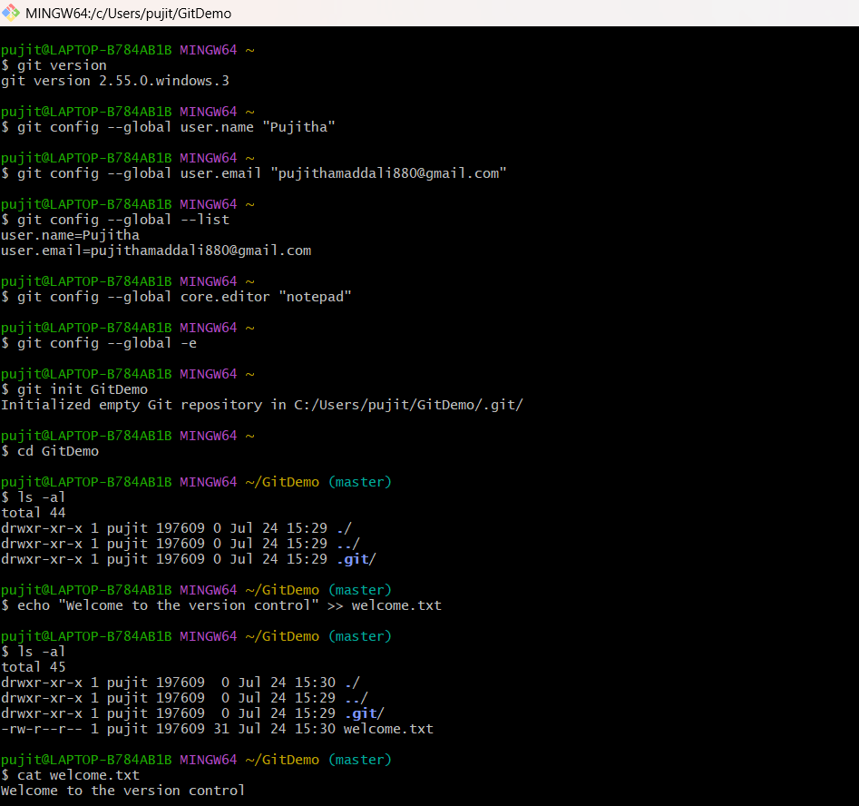

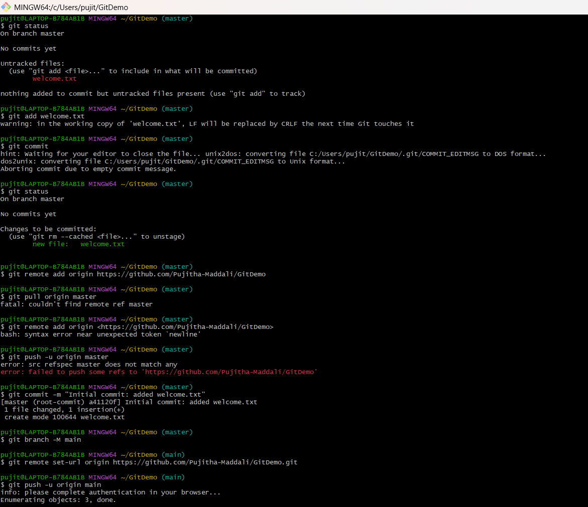

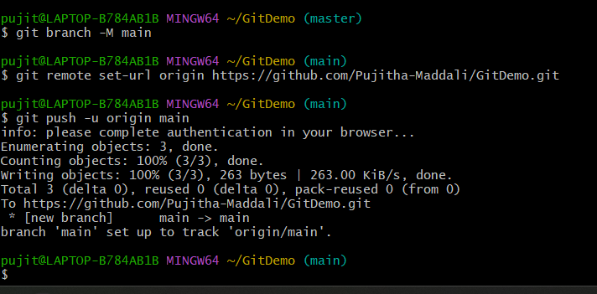

Welcome.txt commited into GitHub:
